Instructions to the Job Talk Workshop.

The entrance to Job Talk is on the side of the building. The cross streets for the entrance is 25th and Florin.

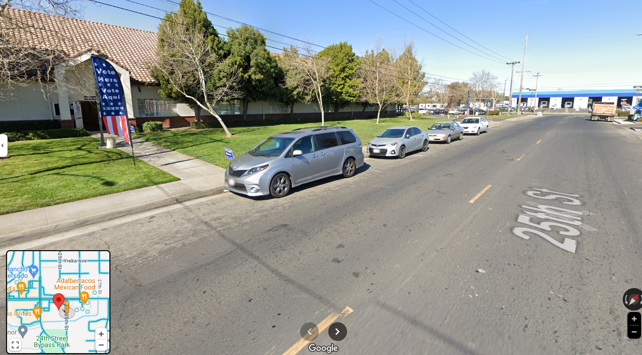
Please enter the building from the side. A staff will be next to the door to greet you.

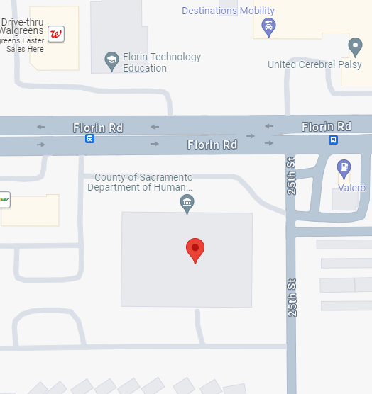
Please use the side entrance for Job Talk.

