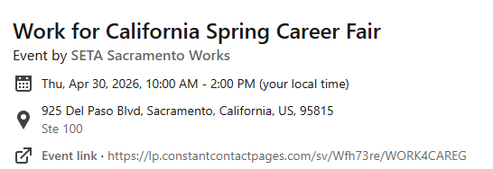
Meet with state recruiters to learn about career opportunities. Attend seminars to learn how to navigate the state's application process.

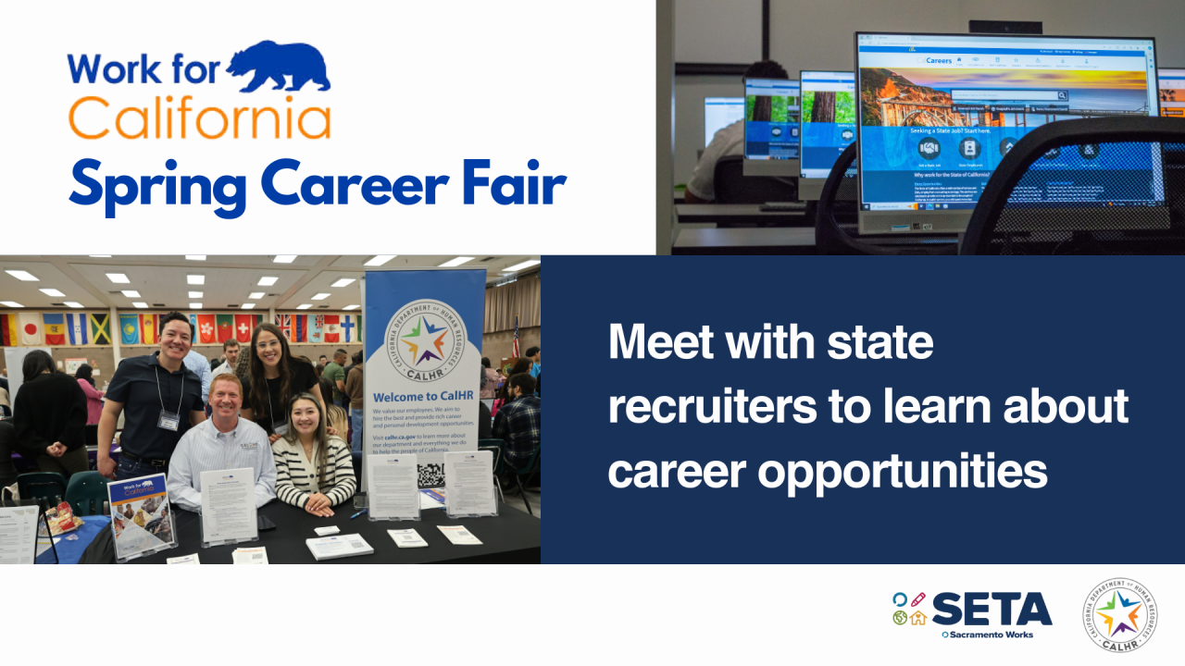
Register: https://lp.constantcontactpages.com/sv/Wfh73re/WORK4CAREG

