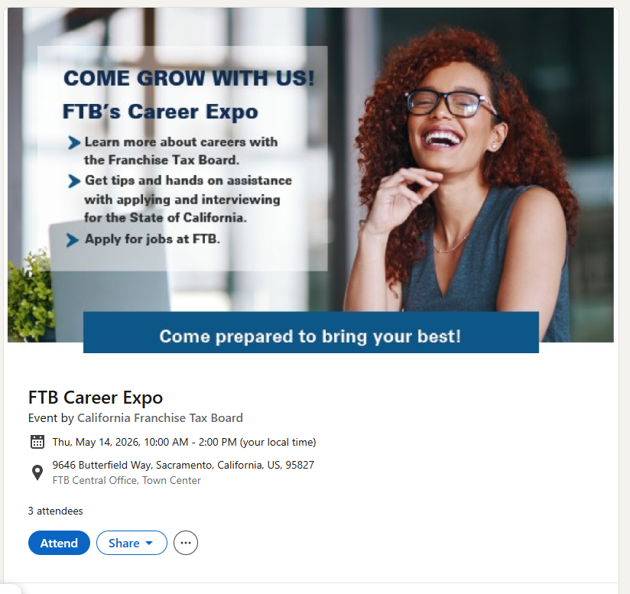
Franchise Tax Board Career Expo

