CalJOBS Invite Template:
Subject: “How to Apply for a State Job/SOQ”
We would like to welcome you to CalJOBS. You are invited to attend the “How to Apply for a State Job/SOQ”. We will provide a variety of resources that can help you get the most of applying for a State Job/SOQ and strengthen your job search. You can register on CalJOBS for this event. Upon completion of registration you will be forward the Zoom meeting ID number and the password.

Event ID: 819656
How to register:
Click on Other Services Appointment Center Event Calendar
Clear the calendar Reset Filter
Enter the Event ID # 819656
Click How to Apply for a State Job/SOQ on 10/05/2020 @ 2:00pm
Review, scroll down and register.

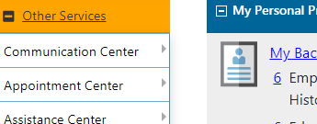Clink on Appointment Center ---
Event Calendar

Clear calendar/reset filter.

Enter event ID # 819656
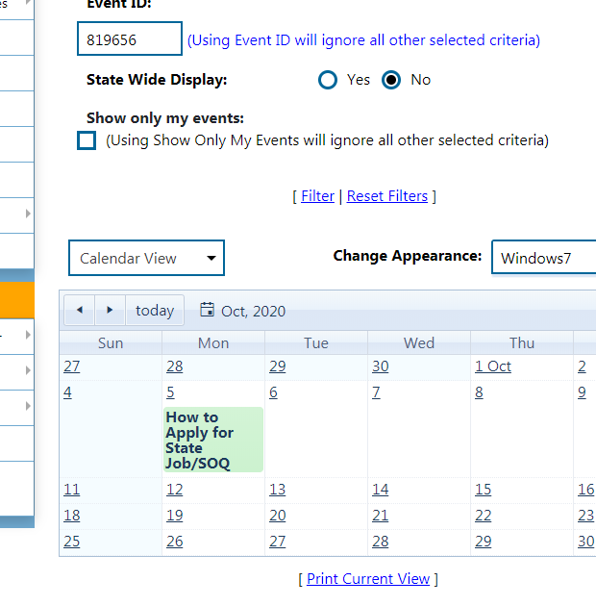
Clink on “How to Apply for State/ SOQ event.
Scroll down and clink Register.

