- promote your mature edge  The Mature Edge Job Readiness Program  Presents  BACK TO WORK 50+ Career & Resource Fair  Friday, June 5, 2015  11:00am – 2:00pm  Conzelmann Community Center  2201 Cottage Way, Sacramento, CA 95825  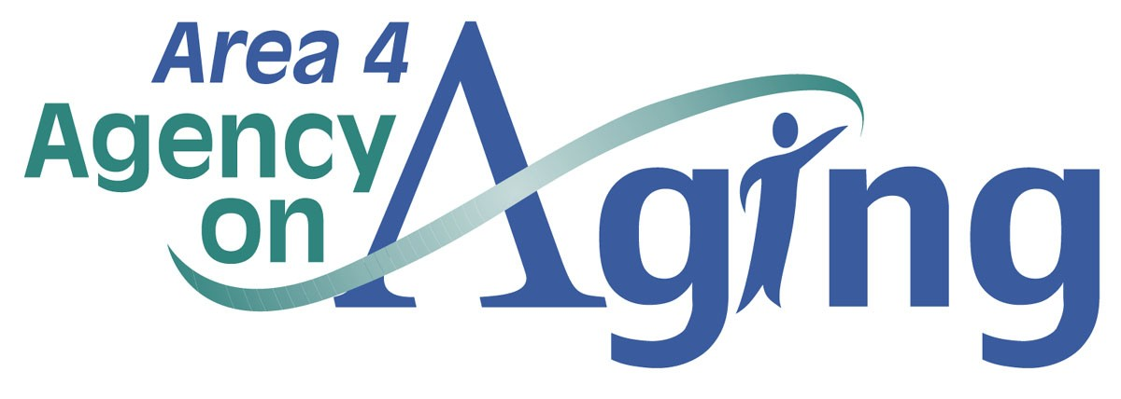  This Fair is funded by the AARP Foundation through a grant to Sacramento Employment and Training Agency (SETA) |  | CalPERS, River City Staffing, Craig Cares, ACC Senior Services and Other Employers  Melissa Washington  Key Note Speaker Intergenerational Workplace &  LinkedIn  Senior Friendly Resources  How To Get A State Job  2260 Park Towne Circle  Sacramento, CA 95825  916 486-1876  www.a4aa.com  Bobby Olwell –more info

